\
69

Peer Consultation Process
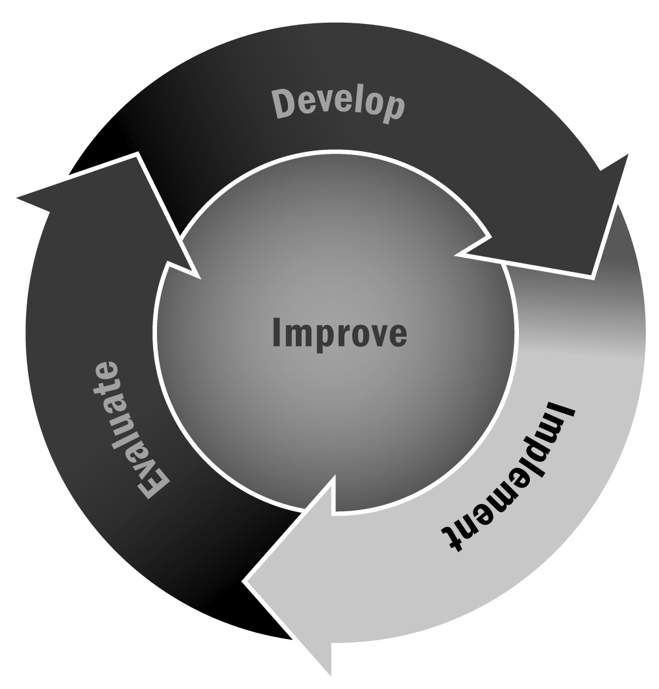
In Chapter 4, you learned that even with a focus on setting an environment for positive behaviors, sometimes there are disruptions that need to be addressed. Giving young people a chance to talk through issues and come to mutually agreeable solutions will empower them to solve problems on their own and will create a safe environment for all youth.
Directions: This process is designed to allow a group of people to discuss an issue in a productive, non-confrontational way. This can be an issue for one person, between two people, or among many in the group. The process has been successful with people of all ages, as it gives young people a chance for their voices to be heard, as well as allowing adults a forum for uninterrupted sharing. There are many variations on peer consultation (sometimes called mediation), so you should structure this in the way that works best for your program and youth who attend.
The Roles
The Coordinator/Timekeeper. In all cases, you should designate or let the group choose a coordinator or timekeeper. The coordinator/timekeeper will notify all involved of the start and end time of each two-minute segment. It is important for the group to not interrupt the individual as he or she is explaining the issue or problem, and a coordinator can be critically useful in reinforcing this.
The Consultant/Mediator. In some cases, you may also wish to have one person serve as the consultant/mediator. The individual or group will ask questions to clarify and resolve the issue and may lead the group in a brainstorming session for alternative solutions. It is possible to structure this so that the group acts as a coordinated mediator where everyone asks questions, but often it is helpful to have one person who facilitates the process.
The Listener(s). In some cases, you may wish to do this as a small group. If two young people have a disagreement, for example, it may be best for those two to work with a timekeeper, a consultant, and one objective listener to solve the problem. Sometimes setting up a safe zone (also known as a mediation center or peace corner) in the program space where youth can resolve these issues is beneficial. Other times, you may wish to go through this process as a larger group. In this case, you will likely have a group of listeners who will both listen and ask questions to help resolve the issue.
The Rules
- Use active listening to understand.
- Show respect when someone else is speaking by being silent and letting them finish.
- Remain objective. Describe what happened and how it made you feel.
- Use “I statements” to describe your feelings. For example, “I felt angry when you knocked me down during basketball.”

The Process
1 minute | Introduction | The timekeeper and consultant review the process and rules.
2 minutes | Sharing | The individual(s) with issue explain(s) the issue to the group (group does not talk). The individual(s) should explain their version of what happened and how it made them feel.
2 minutes | Clarifying and Additional Information | Group can ask individual(s) clarifying questions to fully understand the issue.
2 minutes | Defining the Issue | The consultant/mediator restates the issue and details as he or she understands it.
2 minutes | Brainstorming Solutions Part 1 | The individual(s) describe any strategies they have used so far to resolve the issue and the reasons those strategies have not worked (group does not talk). The individual(s) may also describe any other strategies not yet tried that they think may solve the issue.
2 minutes | Brainstorming Solutions Part 2 | Listeners may suggest alternative solutions that the individual(s) have not tried yet.
2 minutes | Selecting a Solution | The individual(s) may reflect on any strategies suggested by the listeners and discuss (one at a time) which solution is best for all parties. The individual(s) should think through which solutions are best, which solutions will not work and why, and whether a compromise is possible.
1 minute | Closing | The consultant/mediator should ask the individual(s) whether there is anything else they need and should thank them for participating in the process.

Peer Mediation Worksheet
1 minute  Consultant | Introduction
2 minutes  Individual(s) | Sharing: Describe the issue and how it made you feel
2 minutes  Consultant, Individual(s), Listener(s) | Clarifying and Additional Information: Ask questions to understand.
2 minutes  Consultant | Defining the Issue: Restate the issue as you understand it.
2 minutes  Individual(s) | Brainstorming Solutions Part 1: Describe solutions that you have already tried.
2 minutes  Consultant, Individual(s), Listener(s) | Brainstorming Solutions Part 2: Suggest additional solutions that may resolve this issue.
2 minutes  Individual(s) | Selecting a Solution: What solutions will work, what will not, and is there a compromise?
1 minute  Consultant | Closing

